Scouring Machine

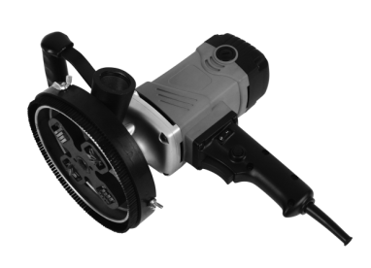

Important Instructions
Important instructions and warning notices are allegorated on the machine
by means of symbols:

Before you start working, read the operating
instructions of the machine.
Work concentrated and carefully. Keep your
work- place clean and avoid dangerous
situations.
In order to protect the user, take precautions.

During work you should wear goggles, ear protectors, dust mask, protective
gloves and sturdy work clothes.

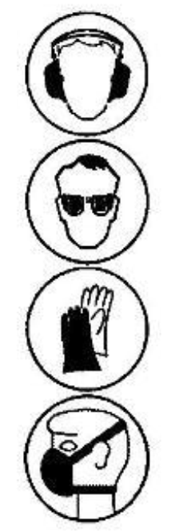

wear ear protectors

wear goggles

wear protective gloves

wear a dust mask

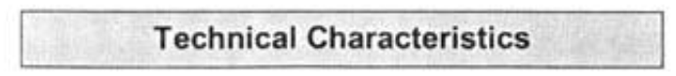

Rated Voltage:
Power Input:
Frequency:
Load Speed:
Max Milling Head Diameter:

230-240V
1500W
50 Hz
2500-4500/min
140 mm

Collet:
Protection Class:
Degree of Protection:
Weight:
M14, male thread
II
IP 20
5.3 kg

Scouring Machine with milling head. Allen key and operating instructions in
a metal case

The Scouring Machine is indented for professional use .
With its milling head, the tool is intended to be used to remove loose
plaster, glue and old paints (e.g. graffiti) in combination with an industrial
vacuum cleaner
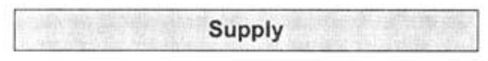

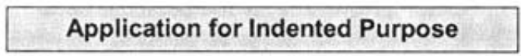

Safe work with the machine is only possible if you read

this operating instruction and the safety instructions
completely and follow the instructions contained strictly.
Additionally, the general safety instructions of the leaflet
supplied with the tool must be observed. Prior to the first
use, the user should absolve a practical training.

If the mains cable gets damaged or cut during the use, do not
touch it, but instantly pull the plug out of the socket. Never use
the tool with damaged mains cable.

The tool must neither be wet nor used in humid environment.

- Do not use the tool near explosive materials (petrel, dilution).
- Do not work with materials containing asbestos.
- Prior to every use, check the tool and its cable and plug. Have
damages only repaired by specialists, Insert the plug into the socket
only when the tool switch is off.
- Plug and switch the machine off if it is not under supervision, in case of
putting up and stripping down the machine, in case of voltage drop or
when fixing or mounting an accessory
- Switch the machine off if it stops for whatever reason You avoid that it
starts suddenly and not under supervision.
- Before starting your work, check the proper seat of the cutting bit and
the individual stars.
- Check the milling head before every use. Do not use damaged or
sluggishly running milling stars.
- Make sure that the tool was mounted properly, and let it run idly in a
safe position for 30 seconds. Stop the tool immediately if you found
considerable vibrations or other defects.
- Don't use the machine if a part of the housing is damaged or in case of
damages on the switch, the cable or plug.
- Electrical tools have to be inspected visually by a specialist in regular
intervals.
- After interruption of your work, restart the tool only after having made
sure that the milling head and the stars are moving freely.
- Do not touch rotating parts.
- Persons under 16 years are not supposed to use the tool.
- Keep the handles dry, clean and free of oil and grease.
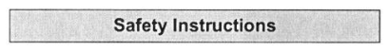

Caution marks!

        - Attention! The milling head still runs for a little while after the
machine was switched off.
        - When working with the machine, wear ear protectors, dust mask
and goggles.
        - Always hold the machine with both hands.
        - Consider the tool's reaction torque.
        - Make sure that persons in the work space are not endangered by
Particles flying around.
        - In order to avoid the star holder and the milling stars get damaged,
work very carefully on edges, corners or extreme transition.
        - Do not work on surfaces with steel reinforcements which lie open.

For further safety instructions please refer to the enclosure!

First, check the correspondence between voltage and frequency against the
data mentioned on the identification plate. Voltage differences from + 6 %

to -
10 % are allowed.

The tool includes a start*up speed limiter to prevent fast expulsion fuses
from unindented responding.

Short-time operation

ON:
Press the ON/OFF switch.

OFF: Release the ON/OFF switch.

Long-time operation (only for workings with Floor Guiding System)

ON:
Keeping the ON/OFF switch pressed, push in the arrestor button.

OFF: Press and release the ON/OFF switch again.

Attention!
If the machine stops for any reason or due to power failure,
immediately release the arrestor button by pressing the ON/OFF
switch, to avoid sudden starts in unattended condition (physical
hazard).
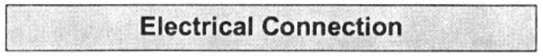

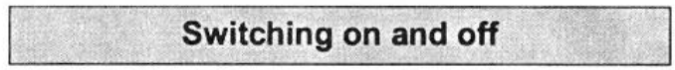

Attention!
Pull out the mains plug before retooling,
The cutting stars may be hot.
Wear protective gloves!
Change only the milling stars.
In case of damage, the capstan may be replaced only in an
authorized service centre.

Remove the three wing screws from the height adjustment (refer to
following section). Remove the brush rim and the height adjustment.
Open the Allen screw M8 ① using the supplied size 6 Allen key. Attention!
The screws have a left-hand thread.
Holding the bush ②for the capstan ⑤with the stars③and the thrust
washers ④. Put the new stars on. Fix the component parts referring to the
drawing.
Attention! Use only Allen screws with locking fastener.

Dust occurrence during milling may lead to sticking of the stars.
This will result in reduced milling performance and increased wearing.
Make sure that the stars are moving freely and, if sticked, unbind them
using a suitable tool (e.g. pliers).
Attention! The milling stars might be hot.
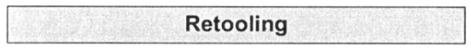

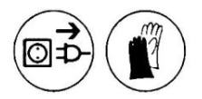

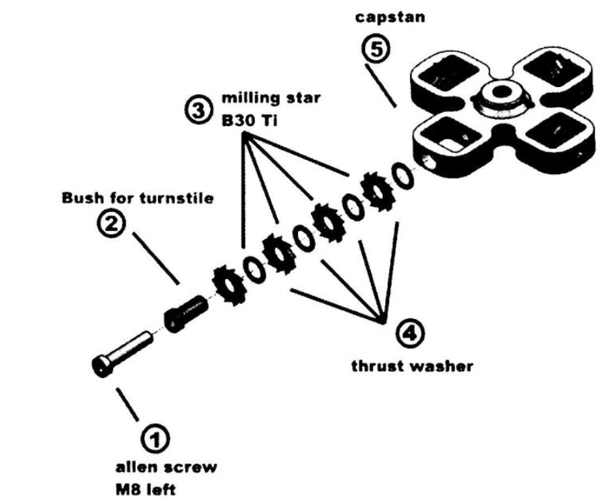

The machine includes a height adjustable protective hood

1. Open the three wing nuts
2. Pull the brush rim down till
the depth gauge can be turned
3 Adjust the required milling
depth.
4. Push the brush rim up again
5. Retighten the wing nuts

Dust which occurs during your work is hazardous to health. That is why it is
advisable to use a deduster and to wear a dust mask For the XM 150, it should
be connected to a professional industrial vacuum cleaner ,which can be connected
directly to the protective hood's 38ram hose connector
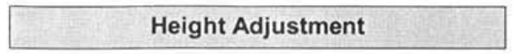

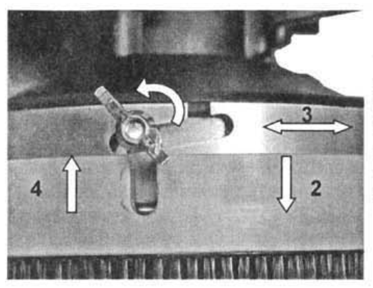

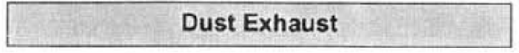

Before the beginning of the maintenance or repair works you
have to disconnect the plug from the mains,

Repairs may be executed only by appropriately qualified and experienced

personnel.
After every repair the machine has to be inspected by an

electric specialist. Due to its design, the machine needs a minimum of care
and maintenance. However, the following points have to be observed:

- Always keep the power tool and the ventilation slots clean.
- During work, please pay attention that no particles get inside the
machine,
- In case of failure, a repair has to be carried out by an authorised

service workshop.

Raw Material Recycling instead of Waste Disposal

In order to avoid damages on transportation, the tool has to be delivered in
solid packaging. Packaging as well as unit and accessories are made of
recyclable materials and can be disposed accordingly.
The tool's plastics components are marked according to their material,
which makes it possible to remove environmental friendly and differentiated
because of available collection facilities.

Only for EU countries

Do not dispose of electric tools together with household waste
material!

In observance of European Directive 2012/19/EC on waste
electrical and electronic equipment and its implementation in
accordance with national law, electric tools that have reached
the end of their life must be collected separately and returned
to an environmentally compatible recycling facility.
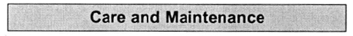

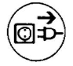

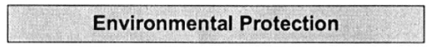

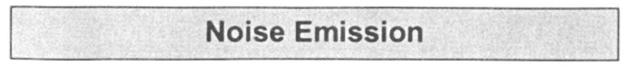

The indication of noise emission is measured according DIN 45 635，part
21．The level of acoustic pressure on work site could exceed 85 dB(A)：in
this case protection means must be used．

Wear ear protectors!

The typical hand—arm vibration is below 2．5 m／s²．
Measured values determined according to EN 50 1 44．

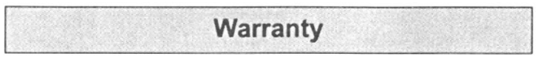

According to the general supply conditions for business dealings，suppliers
have t0 provide c0 companies a warranty period of 1 2 months for redhibitory
defects ． (To be documented by invoice or delivery note ． )
Damage due to natural wear， overstressing or improper handling are
excluded from this warranty．
Damages due to materiaI defects or production faults shaII be eliminated
free of charge by either repair or replacement．
Complaints will be accepted only if the tool was returned in non-dismantled
condition to the manufacturer or an authorized Eibenstock service centre．

